

* Customer Service Excellence & Risk Management
* Relationship Skills Development & Negotiation Management
* Business Writing and Report Development
* Business Intelligence and Data Warehousing Strategy
* Critical Thinking and Problem Solving - Transformational Leadership for Executives
* Communication Skills Development
* Business Continuity & Disaster Recovery Planning
* Refresher courses for Scrum Masters
* Refresher courses for Certified Agile Coaches
* Blockchain Solution Architecture Training
* Supply Chain Management
* Information Cyber Security
* FinTech Advisory
* Evolution of Project Management

<https://www.nigerianseminarsandtrainings.com/tprovider/255/Tom-Associates-Training>

[https://www.mctimothyassociates.com/wp-content/uploads/2021/11/2022-Training-Calendar-McTimothy-associates-Consulting-Limit 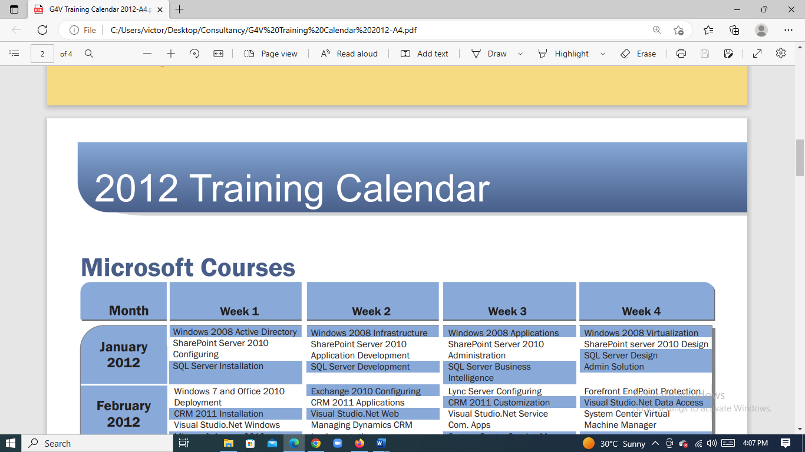ed.pdf](https://www.mctimothyassociates.com/wp-content/uploads/2021/11/2022-Training-Calendar-McTimothy-associates-Consulting-Limit%20#ed.pdf)